Hello, thank you for using the Snap-On Power Tools Test Manager. This software was developed by Jackson Bothmann, an intern in the Power Tools group, for use in the Snap-On Tools Kenosha location. It is designed to be able to track and control testing fixtures that use Click PLCs. In order to operate successfully, PLCs will need to be configured properly, and connected to the PC via RS485 cable. More information will be provided in the PLC setup section.

**Installation:**

Place the entire directory (the folder that contains this file) into a location of your choice. Program Files is the most appropriate place. Note that adding and editing files in the Program Files directory requires administrator privilege. This keeps the files that the application depends on safe. However, almost any location will do.

Launching the application is as simple as running Test Manager.exe. You will probably want to make a shortcut to the application in an easy to find place, like the desktop or the start menu.

**Startup:**

Upon launching the program, the user will encounter a mostly empty window. At the top of the window, there are a few dropdown menus which contain options to configure your stations. The center of the screen is where stations will be visualized. At the bottom of the screen, there are some broadcast controls which can be used to control multiple stations at once.

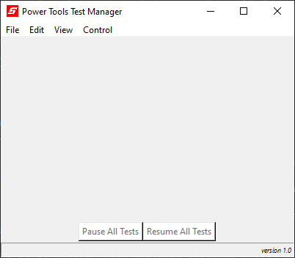

-Configuration Controls

-Data Viewer

-Broadcast Controls

If the user has a *.JSON session file, they can open it with File – Open Session, which will be explained later. Otherwise, stations will need to be added individually.

**Add Station:**

To add a station to the program, navigate to Edit – Add Station. In the first field, the user should input the Slave ID of the PLC that they want to connect to, which is an integer between 1 and 247. This value is written to the PLC upon programming. In the second field, the user should input the name of the station. This name should be unique and descriptive, as it will be the primary identifier for stations on the main viewer. The third field gives the user the opportunity to record a subtitle containing some additional information, such as a relevant serial number.

Next, there are 32 numbered areas for configuring the types of data which will be used by the station. Each number corresponds to the PLC’s float register at the address which is 100 greater than the number – for example, entry 1 corresponds to the DF101 register, entry 2 corresponds to the DF102 register, etc. The first and larger entry for each is the name of the datum, followed by the smaller entry, which can be used to specify the units. Lastly, each data type has a checkbox; checked data types will appear on the main viewer, while unchecked ones will not.

Data Type Characteristics:

-Number

-Name

-Unit

-Show Station

Finally, there are a few controls at the bottom, including some buttons which will conveniently check or uncheck all boxes at once. Selecting Add Station will add the station with the given parameters to the main program, and Add and Close will add the station and exit the dialog. Close will exit the dialog without making any changes.

Once a station has been added, the station will appear on the main screen. For example, here are three similar stations, with four different cycle counters, representing four different test fixtures on the station. These will simply display 0.00, and the status will be “Offline” until the program is connected to the serial network, which will be explained later. Each station display has a few useful buttons: The gear icon will bring up the Edit Station menu, the pages icon will copy the station’s data to the user’s clipboard, the Pause/Resume button will toggle the station’s activities on or off, and the More Controls button will bring up the control dialog.

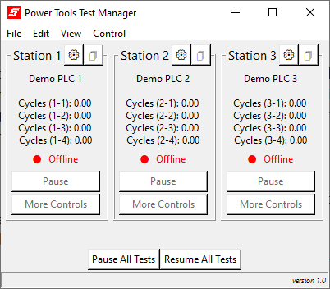-Station Number (PLC Slave ID)

-Station Title

-Edit and Copy buttons

-Station Data

-Station Status

-Pause/Resume button

and Controls button

**Edit Station:**

The user can edit a station which has already been added by navigating to Edit – Edit Station. This dialog is very similar to the Add Station dialog. The user can select which station to edit by using the dropdown menu at the top.

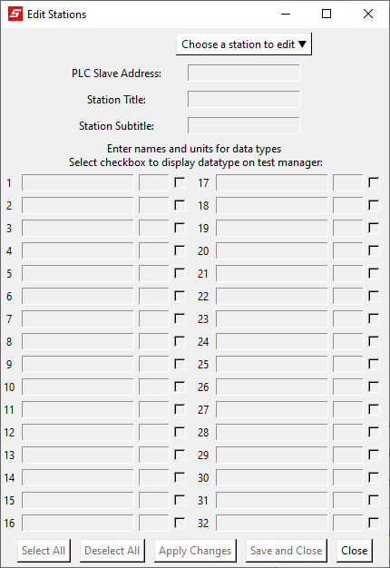

-Station Selector Dropdown

**Delete Stations:**

To delete a station, navigate to Edit – Delete Station. A dialog will appear, where the user can select a number of stations and delete them. Every station which is selected will be permanently removed from the program, while unselected stations will be unaffected. Select the Delete Stations button to finish the operation.

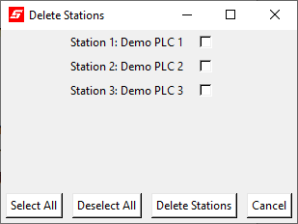

There is also a way to remove stations from the main viewer without permanently deleting them.

**Hide/Show Stations:**

To hide a station from the main viewer without permanently deleting it, navigate to View – Hide/Show Stations. A dialog will appear, which the user can use to select which stations will be shown on the main viewer. A selected station will be shown, while a deselected station will be hidden. Select the Save button to submit your changes

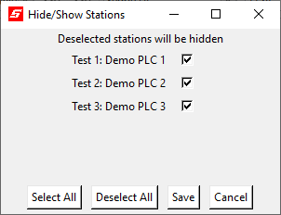

**Lock Display:**

It may be important to the user to disable control of the program in certain circumstances. If that is the case, navigate to View – Lock Display. The user may lock the program without a password, or with a password entered. While the display is locked, most functions and controls will be disabled.

**Save Session:**

As mentioned previously, the user has the opportunity to save their current configuration as a *.JSON file. Navigate to File – Save Session. Selecting this function will open a system dialog, which will allow the user to create a new file.

**Open Session:**

Similarly, the user may recall a previous configuration from an existing *.JSON file. Navigate to File – Open Session. Selecting this function will open a system dialog, which will allow the user to find and open a file. The saved stations will be automatically added to the main viewer.

**Connect to Port:**

Once the user has configured the main viewer as they desire, the next step is to connect to the RS485 network to monitor and control their stations. Ensure that the RS485 connection is properly established, then navigate to File – Connections, and this dialog will appear. Use the COM port selector dropdown menu to find the port which you would like to connect to. The user may use the Rescan button to refresh the list of available ports. Finally, establish the 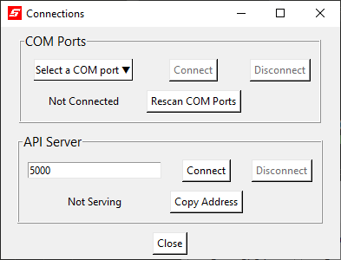connection by selecting the Connect Button.

-COM Port Selector Dropdown

-Refresh available ports

-Establish Serial Connection

If the user is unsure of which COM port to select, the best way to find the correct port is to open your computer’s Device Manager. On a machine running Windows 10 or another version of Windows, it will look something like this:

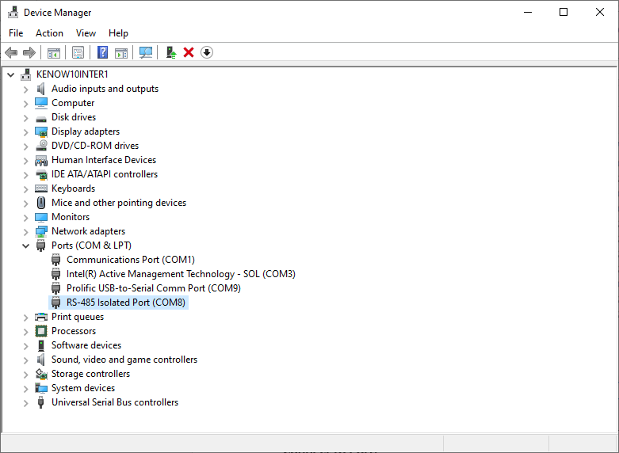

Open the Ports (COM & LPT) tab or similar. If this tab does not appear for you, Select View – Show Hidden Devices. I have identified the device that I am using to connect to my serial network (RS-485 Isolated Port). If the device does not appear, it is likely that the device’s driver is not installed. The COM port that the device is using (COM8) is displayed next to the device name. Connecting to COM8 within the Test Manager dialog will connect to this device and immediately begin communication with the RS485 network.

Once the Test Manager is in communication with the serial network, you will be able to monitor your stations’ status, pause and unpause them, and toggle other controls. Next, the Test Manager can begin serving the network, allowing users running the Test Viewer to connect.

The server can be enabled from the same dialog. Use the entry field to input the network port that you would like to use. The network port is an integer between 0 and 65536. Some of these ports may already be in use or reserved. If you are unsure which port to use, 5000 is a safe choice. Next, use the Connect button to start serving. The dialog will display the address that Test Viewer users can connect to. Select the Copy Address button to save the address to your clipboard.

-Port Entry

-Connect Button

-Copy Address Button

**Label Controls:**

In addition to the 32 points of data that the Test Manager collects, there are also 32 toggleable controls attached to each station, mapped to registers C101 through C132. In order to define them, navigate to Edit – Label Controls. Here you can select a station from the dropdown menu, and use the entry to label each control register. For example, Station 1 has four individual fixtures, and control registers 1 through 4 are used to enable or disable each fixture. They have been labeled appropriately, and can be saved by clicking the Apply or Save button.

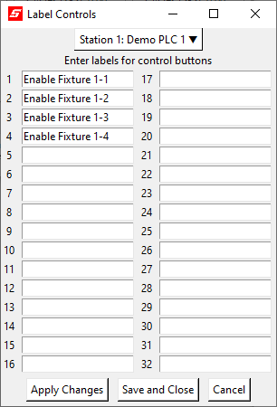

Now that the control coils are labeled, we can use them.

**Station Controls:**

This menu can be accessed either through the More Controls button on each station’s display, or via Control – More Controls. The desired station can be selected using the dropdown. Once again, the user is shown a list of 32 item. Each item shows the number of the control, the label that has been assigned to it, and a button. The button displays whether the control is currently on or off. Selecting it will signal the stations to switch from on to off, or off to on.

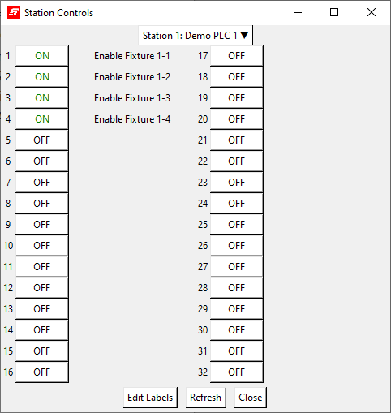

Selecting the Edit Labels button will return the user to the Label Controls dialog. Selecting Refresh will update the dialog to show the most recent values of the controls.

**Pause/Resume Stations:**

While the user can easily pause or unpause stations from the main viewer, the user might want a more focused dialog as well. Navigate to to Controls – Pause/Resume. From here, the user can see the status of all stations. For example, this dialog shows that there is one station that is in progress, and two that are offline. Selecting the status button will signal the station to pause if in progress, or resume if paused.

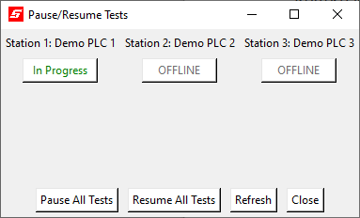

Broadcast controls are also included. Select Refresh to update the dialog, and show the most recent status of all stations.

**Write To File:**

It may be useful for the user to create a simple text file output representing the current state of their stations. If this is the case, navigate to File – Write To File. The user may select which station they would like to be represented on the text file. Once the user has made their selections, they may select Save As to open a system dialog prompting them to create a new *.txt file.

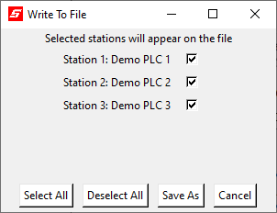

The new file will include a header which gives the date and time that the file was created, and a section with each selected station.

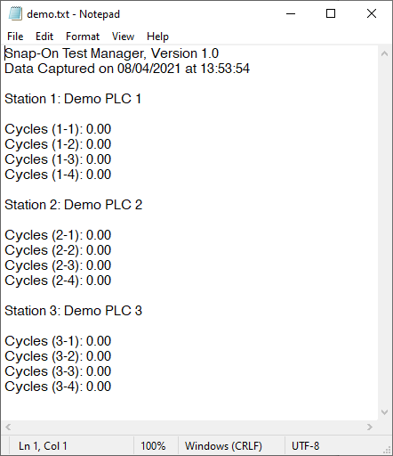

-Header

-Station Info

**Themes:**

The Test Manager application can be visually configured to the user’s liking. Navigate to View – Theme. From this dialog, the user can select a color theme for the software, the font for all text, and the size for all text.

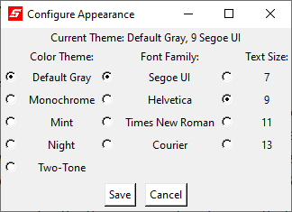

The application’s default values are shown selected here. It is left to the user to find an appearance that suits them.

Tip: Courier is a monospaced font. If there is cut off text anywhere in the application, it may help to set the font family to Courier.

Test Manager is distributed with five themes, four fonts, and four text sizes. More may be added through the use of configuration files.

**Configuration Files:**

The Test Manager application uses the contents of three *.JSON files to configure itself upon startup. Edit these files with your favorite text editor to modify this behavior to your liking. Make sure that these files use proper JSON formatting. If the Test Manager directory is in a protected space, like Program Files, the text editor must be run as administrator to make changes.

**config.json**

This file is structured as a JSON object with the following attributes:

“comport”: Set this to a COM port to be automatically connected to it upon startup.

This must either be an integer between 1 and 256, or a string in the form “COM<port>” where <port> is an integer between 1 and 256.

Set as null if you don’t want this behavior on startup.

“netport”: Set this as a net port to be automatically begin serving upon startup.

This must be an integer between 0 and 65536

Set as null if you don’t want this behavior on startup.

“file”: Set this as a filepath to a session file to automatically load it upon startup.

This must either be a string filepath, or an array of string filepaths

Filepaths must use forward slashes as separators. Windows uses backslash separators, so they must be changed.

Set as null or as an empty array if you don’t want this behavior on startup.

“lock”: Set this as true if you want the application to be locked on startup. False otherwise.

“pass”: Set this as a string if you want to add a password to your lock on startup.

Set this to none if you want to lock without a password.

If “lock” is false, this option does nothing

“theme”: Set this as the title of an installed theme to use it upon startup.

This must be a string. Installing themes is explained in the themes.json section

“fontFamily”: Set this as a name of a font to use it on startup. String.

“fontSize”: Set this as a number to use that text size. Integer.

**fonts.json**

This file is structured as a JSON object with the following attributes:

“families”: an array of fonts names to be added to the theme menu. Strings.

“sizes”: an array of font sizes to be added to the theme menu. Integers

**themes.json**

This file is structured as an array of JSON objects, each representing a theme to install.

Each theme item has the following attributes:

“title”: The name of the theme. Must be a string.

“bg”: The background color of most elements. Must be a string containing a valid color.

“fg”: The text color of most elements. Must be a string containing a valid color.

"selectbg": The background color when highlighting text or selecting a button.

Must be a string containing a valid color.

"selectfg": The text color when highlighting text or selecting a button.

Must be a string containing a valid color.

"contrast_bg": The background color of interactive elements, like buttons and entries.

Must be a string containing a valid color.

"contrast_fg": The text color of interactive elements, like buttons and entries.

Must be a string containing a valid color.

"contrast_selectbg": The background color of interactive elements when selected.

Must be a string containing a valid color.

"contrast_selectfg": The text color of interactive elements when selected.

Must be a string containing a valid color.

Valid Colors:

-A hexadecimal color code, preceded by a number sign, and containing either three, six, or nine hexadecimal digits.

-A color named by the [X11](https://en.wikipedia.org/wiki/X11_color_names) format

**This concludes the tutorial.**

**Thank you again for using Snap-On Power Tools Test Manager.**